Practical - 10
Practical Title: Secure Login/Logout with Sessions, Role-Based Access, Timeout, and Remember-Me Token.

Develop secure login and logout functionality using PHP sessions. Verify password using password_verify(), regenerate session ID after login, restrict dashboard access, implement role-based redirection, session timeout, and optional secure remember-me token.

Theory
- Are sessions started and destroyed securely?
Yes. Sessions are started using session_start() and destroyed during logout using session_destroy(). Session cookies are configured with security settings such as HttpOnly and SameSite.
- Is password_verify() used correctly?
Yes. The password_verify() function compares the entered password with the hashed password stored in the database to authenticate the user securely.
- Is unauthorized dashboard access blocked?
Yes. Protected dashboard pages check whether a valid session exists. If the user is not logged in or the session has expired, access is denied and the user is redirected to the login page.
- Is session timeout implemented?
Yes. A session timeout is implemented to expire inactive sessions after 15 minutes (900 seconds), requiring the user to log in again.
- Are admin and student users redirected to appropriate dashboards?
Yes. After successful login, the user's role is checked. Admin users are redirected to the admin dashboard, while student users are redirected to the student dashboard.

Implementation/ Output/Result
Tags:
• Login form validation using JavaScript and PHP.
• User authentication using MySQL database credentials.
• Secure password verification using password_verify().
• Session management using PHP sessions.
• Session ID regeneration after successful login.
• Automatic session timeout after 5 minutes of inactivity.
• Role-based access for students and administrators.
• Secure logout by destroying the session.
• Redirecting users to their respective dashboards after login.

Output Screenshots:
Admin Login Credentials:
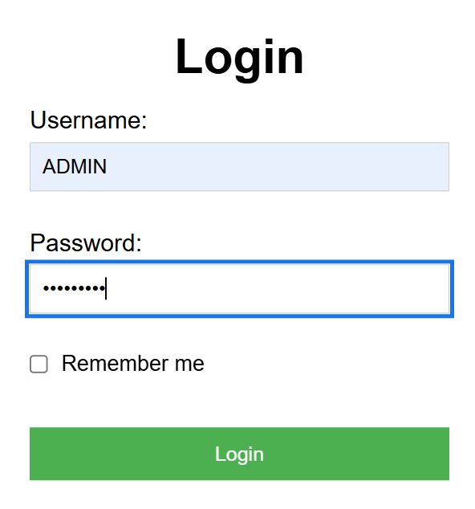
Admin Dashboard:
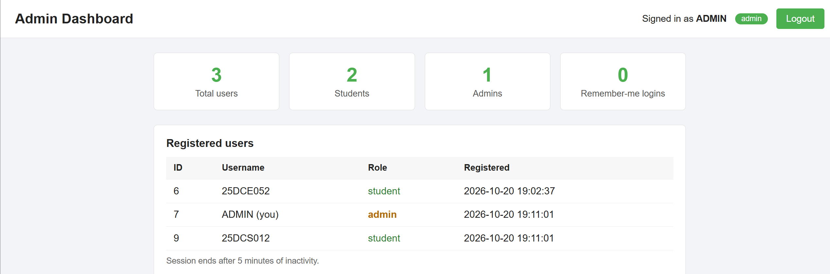

Student Login:
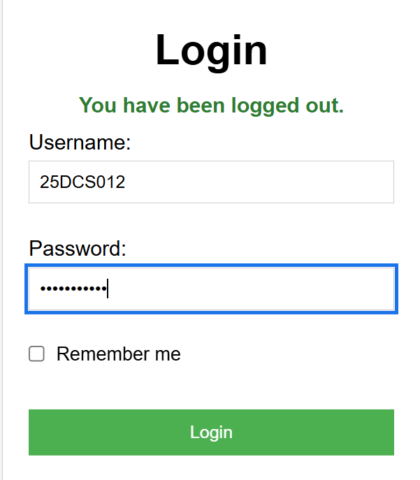
Student DashBoard:
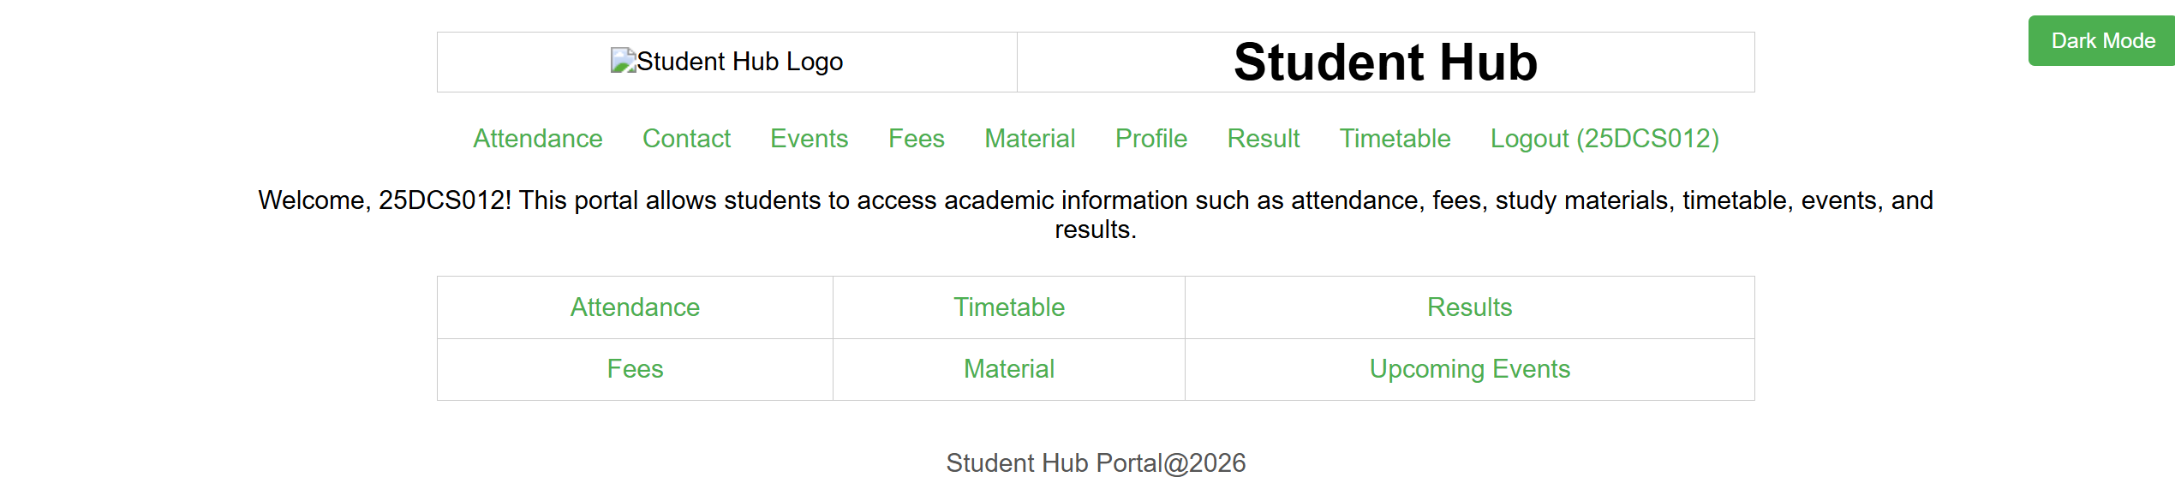

Session timeout(after refreshing page):
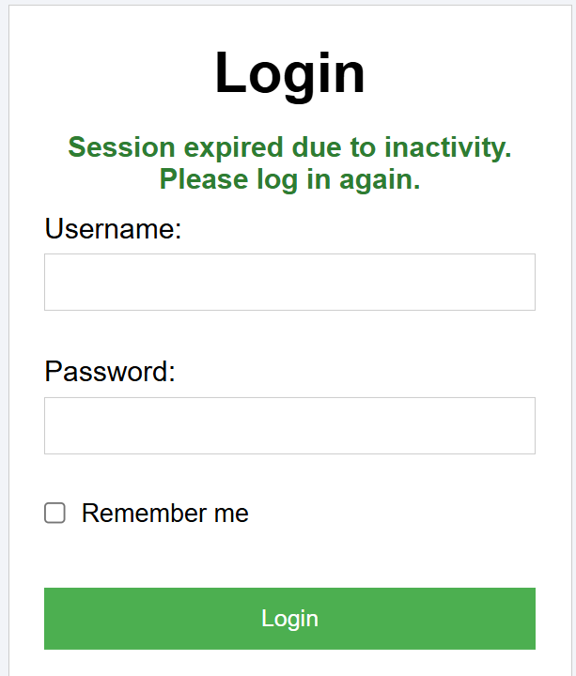

5.Github Link:
https://github.com/HimeshMale/Student-Hub-Portal.git

Challenges Faced:
I wasn’t able differentiate admin and student dashboard like how should I differentiate both.

Learning Outcomes:
I learned how to use data as creadentials at webpage.

Faculty Remarks:

